CHAPTER 2

LITERATURE REVIEW

**2.1 Introduction**

Portfolio optimization as an area of study has got lot of directed research over the decades.

Given the utility and commercial viability of portfolio optimization there has been renewed and continued research through cutting edge tools, techniques.

Treatment of portfolio optimization from Mean Variance optimization(MVO) approach which logically divided the problem into two parts viz. 1.Empirical Observation of past performance 2.Belief about the future performance and optimal choice in that respect.(Markowitz, 1952).

This approach illustrated relation between “Expected returns and variance of returns” culminating into the concept of “Efficient Frontier” to give a desired combination of Expectation of return and Variance.(Markowitz, 1952).

The approach leads to concentration of weights in few stocks that leads to high risk in investment.This lack of risk diversification is frought with failures during occurance of extreme events like market falls.(Min *et al.*, 2021).For stocks with sparse historical data estimation mean and variance of stocks could have high errors resulting in high risk.(Jobson and Korkie, 1980).For large sample size the computational complexity increases with temporal overhead.MVO approach discourages portfolio selection with increase in returns or variance.(Weng *et al.*, 2020).Markowitz’s modern portfolio theory makes assumptions which are breached in real time like market being perfect without Short sales or shares can be divided into fractions exempted from taxes and transaction costs.(Simos, Mourtas and Katsikis, 2021).MVO model is also criticised due to absence of real word scenarios like boundary and cardinality constraints.(Kalayci, Polat and Akbay, 2020).

Above limitation, needs of changing times coupled with exponential growth in computational power have led many approaches that have solved the problem of portfolio optimization in a much better manner.

**2.2 Developments in portfolio optimization techniques.**

Developments in portfolio optimization techniques can be studied through two dimensional framework one focussing on the Problem and other on Methodology.(Doering *et al.*, 2019)

Problem specific developments relate to more real, accurate problem formulation, diversified definition of risk,use of hybrid simulations coupled with machine learning.

Additional constraints are added the problem and objectives.(Doering *et al.*, 2019)

On the other hand methodology specific developments concentrate on improving computational times and methodological complexity,computational time increase exponentially when the problem solving becomes multi-objective.These focus on meta-heuristic approaches, increasing computational capability through better hardware support,distributed and parallel computing.Methodological complexity related development focuses on lacunae of population based metahueirstics by proposing single point metahueristic approaches.Hybridiation of methods is an important trend which can be further analysed given its richness and diversity.(Doering *et al.*, 2019)

One other important classification for analysing developments that requires mention on the trading strategy side is passive and active trading strategy depending on the investor behaviour of replicating the index or trying to actively beat it.(Shi *et al.*, 2022).More efforts have been made on beating the market through active trading strategies.

The number of such development and strategies is vast enough to be beyond the scope of discussion in this paper.Certain techniques have been discussed following text to enrich the perspective on this area.

**2.2.1 Traditional Machine learning based Methods**

Machine learning based methods have proved useful overtime to solve multi-dimensional prediction problems.Stock data contain time series data in various forms like stock open/close price,volume,return,volatility.(Enke and Thawornwong, 2005).Stock price movement over the temporal dimension provide necessary features required to train machine learning models. Variables like technical indicators,financial variables and macro-economic variables are considered the most important variables.(Tsai and Hsiao, 2010).However over the years the exponential growth in social media and web based content site has been found to be an important influencer of stock market.(Li *et al.*, 2020).The search more data new data influencer is an on-going one.

Ensemble models like Adaptive Boosting(Adaboost), Gradient boosted decision trees(GBDT) and Extreme Gradient boosted tress(XGBoost)(Chen *et al.*, 2021) are both as for classification and regression problem solving.

The scheme of use includes use of these models as binary classifiers to predict direction of market.Experiments have resulted in higher returns than market.(Nobre and Neves, 2019).Use of Extreme Gradient Boosted trees to classify stock trend.(Dey *et al.*, 2016).XGboost model has predominantly been used for classification some experiments have also used XGBoost as regression in stock price forcasting.(Chen *et al.*, 2021).In this study XGBoost model’s hyperparameters are optimised using a meta-heuristic algorithm called firefly.The resulting model is a hybrid model namely IFAXGBoost.(Chen *et al.*, 2021)

Another Tree based ensemble model Random forest has been used to predict the stock price direction.Using technical indicators like relative strength indicator(RSI),stochastic oscillator to predict increase or decrease in price of stock after ‘n’ days.Being a classification problem metric like precision and recall has been used.(Khaidem, Saha and Dey, 2016)

Another study that add more classes to vanilla binary classification problem was conducted by

Lohrmann and Luukka,random forest model was used on S&P500 for predicting intraday returns.The four classes were ‘strong positive’,’slightly positive’,’slightly negative’ and ‘strongly negative’ returns.136 variables ranging from technical indicators,fundamental indicators to engineered features were selected chosen which were later pruned using fuzzy similarity entropy measure(FSAE)(Lohrmann *et al.*, 2018).Multiple strategies involving permutation and combination of long(buy) and short(sell) were compared with the benchmark of long(buy) and hold.The study indicated that classes with strong signals to buy and sell were the most accurately predicted than those with slight buy and sell signals.(Lohrmann and Luukka, 2019).Study combining multiple feature selection methods like principal component analysis(PCA),genetic algorithm(GA) and decision tress(CART) has shown how intersection of PCA and GA and multitersection of PCA,CART and GA for feature selection results in accuracy in the range of 79%.(Tsai and Hsiao, 2010).Bayesian networks have been used to determine the influence of one closing market on the other opening market over 24 hour and 48 hour window around the globe keeping the main index of Sao Paulo stock exchange iBOVESPA as the pivot.This research proves that the markets around the world are interrelated.Results from the research provide mean accuracy of 71%.(Malagrino, Roman and Monteiro, 2018).

**2.2.2 Deep Learning Models**

Deep Learning models are a popular choice for predicting the direction or value stocks.In the recent times technological advancements have led to increased use of Deep learning models due to two primary reasons:first being the availability of enormous volumes of structured and unstructured data at least latency,second being the increase in compute power given advance processing systems like Graphical processing unit(GPU),cloud computing to state a few.

Deep learning models tend to solve for the lacunae of stock data that pose challenges traditional time series models,they work well on non-stationary,non-linear,noisy data.(Niaki and Hoseinzade, 2013).Most popular deep learning models could be classified into three categories viz.standard models,their variants,hybrid models and other models.Popular standard models include feedforward neural network,convolutional neural network and recurrent neural network.Hybrid models are a combination of one or more standard deep learning models or a combination of standard deep learning models and traditional linear models.Others catergory has models like generative adversarial network, transfer learning.Re-inforcement learning models.(Jiang, 2021).

Feedforward neural networks have been popularly used in Artificial Neural Networks(ANN) and Deep Neural Networks(DNN).ANN was used in predicting the closing price of PETR4, traded on BM&FBOVESPA, feedforward multilayer perceptron composed of three layers input,hidden and output layer was used.Best performing model had a time window size of 3 with a prediction of change direction(POCID) accuracy on test set at 93.62% and performed much better than the baseline logit model.(De Oliveira, Nobre and Zárate, 2013). DNN is an advanced version of ANN with more than one hidden layers.Recurrent Neural Network(RNN) is a variation of ANN where the output of previous step is used as input of current step thus capable of remembering immediate past value.However RNN have problem in handling long term dependencies that are solved by Long Short Term Memory(LSTM) which include memory cell that can maintain information in memory for long period of time.

LSTM models have shown promise over years and multiple research attest to the fact.LSTM compared to traditional time series auto regressive integrated moving average (ARIMA) model gives good results in terms of higher accuracy and lower forecast errors.(Siami-Namini and Namin, 2018).Another enhanced use of LSTM model through attention mechanism was used for stock price forecasting after extracting news information in auxiliary role to gauge price movement.Stock price passed through wavelet transform and attention based LSTM was found promising.(Qiu, Wang and Zhou, 2020).A LSTM-DNN based time-series model for stock price prediction was developed using new auto-regression scheme,autoregressive moving pointer model(AMPM)..Herein input output that are fed to LSTM-DNN model are generated through the AMPM model on NIFTY50 data.(Rather, 2021).Ensemble model consisting of deep neural network(DNN),gradient boostd tree(GBT),Random forest(RF) for equal weights strategy with top 10 stock of S&P500 provide daily returns of 25% and 73% per annum.Research also points to the importance of hyperparameter tuning and combining base learners as per the compute power,so does the need to use advanced ensemble integration methods like stacking or superlearning.(Krauss, Anh and Huck, 2017)

Reinforcment learning(RL) frameworks aims at solving Markov decision problems. RL framework has three major formal elements (i)Sequential decision making(ii)Scalar reward(iii)Delayed feedback.Major components of RL configuration are agent-environemnt,action-reward.The baseline for RL is Markov decision process(MDP) wherein the reward depends on last state and action,current state is the sufficient representation of past.There is a assumption that the agent acts to maximise reward. RL algorithms have two popular classifications viz:value based and policy based.RL have helped in modelling the stock prediction problem closer to real world scenarios be it accommodating constraints or moving away from strict model formalisations.(Singh *et al.*, 2022).

Fig 1:Dominant Algorithms in Modern RL used in Finance.(Singh *et al.*, 2022)

Double Deep Q-Networks

Distributed Deep Q-Networks

Deep Q-Networks(DQN)

Q-Learning

Reinforcement

Learning

Actor Critic Methods

Model Based Methods(MBM)

Value based Method

Policy Gradient Methods(PGM)

Integrating MBM and Model Free Methods

Pure MBM

Stochastic policy Gradient

Deterministic Policy Gradient

Combined PGM and Q-Learning

Use of Policy or Value based RL methodology is determined by the nuances of problem at hand.Q-learning a type of value based approach has been tried very early in combination with nueral networks to achieve better results than the nuero-fuzzy model.The experiment gave 25% better returns in test phase and kept capital out of market in case of volatility or absence of trends.(Neuneier, 1996).Q-Learning compared with policy based method recurrent reinforcement learning(RRL) does not fare equally good on efficiency and simplicity often leading to unnatural problem representation.RRL method was found to be more explainable than Q-learning as well.Run time of Q-learining was almost 150 times that of RRL method.(Moody and Saffell, 2001).In Current times there is a big push on sustainable development,various supra-national organisations including United nations have come up with sustainable development goals.In this vein global investors and organisations want to invest under the paradigm of socially responsible investing(SRI).Enterprises that promote sustainable development score high on Environmental,Social and Governance(ESG) metrics.

SRI has been enabled through an experiment wherein multivariate bidirectional LSTM is used to multiple time series prediction for stock returns for a multi-objective portfolio construction.

Reinforcement learning is used to tune hyperparmaters as per changing market dynamics.(Vo *et al.*, 2019).

**2.3 Summary**

The chapter starts with an overview of traditional portfolio optimization theory and methods.

This provides a baseline over which development in the portfolio optimisation areas have happened.Limitations of MVO methods have been highlighted which broadly relate to their too simplistic view of portfolio optimisation,which has additional nuances added when portfolio optimisation plays in real world scenarios.There is a discussion on how multiple shortcoming have been addressed by new methods due to growth in research and emergence of new computational power in technology.Development in portfolio optimization theory have been logically explained under two emerging trends one being problem specific development where portfolio optimisation has been treated in more complexity nearing the real world situtaions.Other being the methodology specific development that has seen new methods,hybrid methods and computationally intensive methods gaining popularity.

Two areas of developments have been described in detail from dimensions of problem and method enhancements viz. Traditional machine learning methods and Deep learning methods.

Major research in the area has happened in supervised learning space where historical data is used to either forecast the value or direction of stock at various frequnecies.Regression and classification methods have been described highlighting major development in those areas.Ensemble models like XGboost,Random Forest have been illustrated with their use cases of reseach.Linear models like decision trees have also been highlighted for their utiliy.Finally in discussion about the deep learning models which provide solutions to the shortcoming of traditional Machine learning models standard deep learning models like ANN,CNN,RNN and their utility in portfolio optimization space are discussed.Certain variants of standard model and hybrid model find mention.In other category RL models are discussed with their variants and how they help in imbibing constraints in their formalisation.

CHAPTER 3

METHODOLOGY

**3.1 Introduction**

Portfolio optimisation is a data intensive problem solving method.Historical data from stock market is used to derive historical patterns that show the vital statistics of a stock.Indicate the direction of market, reveal a lot of micro and macro relationships.Data granularity can go down to second level information to daily open-close prices some of which is freely publicly available.Traditional method of portfolio optimization relates to Mean Variance optimisation(MVO) that can be programmatically solved used computational tools.MVO tries to find a sweet spot of maximum returns at optimum risk or variance which can be measured through the metric of sharpe ratio.This techniques leads to weights or proportions that could be invested said stocks of portfolio.In this technique temporal pattern of close price of the stock could be used to get both a measure of return and variance in stock.

Machine learning methods of portfolio optimisation on the other hand mostly deal with portfolio optimisation as a supervised learning problem wherein either the direction or value of stock is forecasted thus it turns into either a classification or a regression problem.As per the choice the metric of model performance also change.Metric in a classification problem range from Area Under the Curve(AUC) to metrics like recall,sensitivity or accuracy derived from confusion metrics.In a regression problem metric like Root Mean Square Error(RMSE),Mean Absolute Percentage Error(MAPE) are preferred.

The methodology followed in this study compares the traditional portfolio optimisation methods of mean variance optimization with multiple standards and ensemble machine learning. Forecasts thus obtained are used to simulate trade at multiple time windows to compare the efficacy of one approach over other.

Fig 2.Flow of work

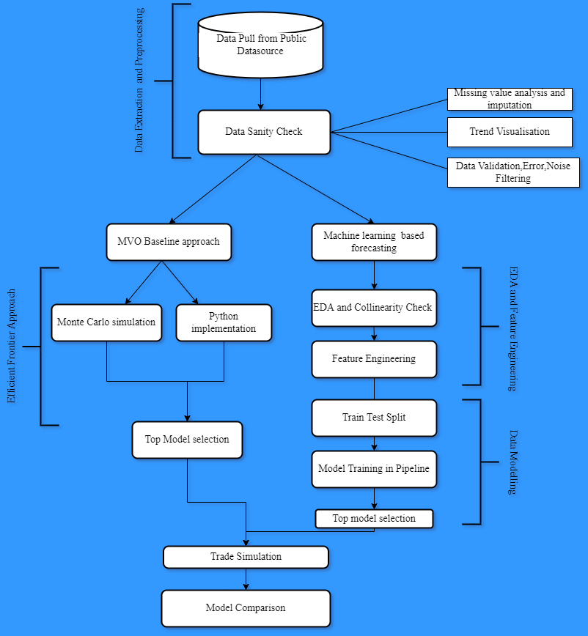

**3.2 Markowitz Portfolio Selection Method:**

Markowitz theory of portfolio optimization is based on mean variance optimization.

For theoretical treatment let’s define the expected returns $R_{i }$ as:

$R_{i }= \sum_{t=1}^{∞}{d_{it} r_{it}}$ return for *i*th security

$R=\sum{ x_{i }}R_{i}$ is the total return ……………..

Where the variables $r_{it}$ is the anticipated return at time *t* per dollar for security *i*.

$x_{i }$ is relative amount invested in each stock,

$x_{i }≥0$ this excludes short sales, $\sum{x_{i }}=1$ (Markowitz, 1952)

Thus for a portfolio with N assets expected return(*E(r)*) can be expressed as:

${E\left(r_{p}\right) = \sum_{i=1}^{N}{x}}_{i}r_{i}$

Variance for such a portfolio can be expressed as:

$σ_{p }^{2}=\sum_{i=1}^{N}{\sum_{j=1}^{N}{x_{\begin{aligned}i \\ \end{aligned}}x_{j}σ_{ij} }}$

Where $σ_{ij}$ is the covariance between the return of *i*th asset and *j*th asset.Mean variance optimization has three constraints under which the variance is minimised with constraints as:

${Min.(σ}_{p }^{2})=\sum_{i=1}^{N}{\sum_{j=1}^{N}{x_{\begin{aligned}i \\ \end{aligned}}x_{j}σ_{ij} }}$

$Return=\sum{ x_{i }}R_{i}$

$\sum{x_{i }}=1$

$x_{i }≥0$

The solution to problem leads the efficient frontier for N risky assets.(Gökgöz and Atmaca, 2012)Fig 3.

Efficient Frontier

Expected return(r)

Opportunity

Set

Global minimum

Variance portfolio

Risk (σ)

Defining the investor’s utility function (U):

$U=E\left(r_{p}\right)-\frac{1}{2}A{σ_{p}}^{2}$

here*“A”* is an index of investor risk aversion.(Gökgöz and Atmaca, 2012)

Thus the final equation looks like:

$U=E\left(r_{p}\right)-\frac{1}{2}A{σ_{p}}^{2}$

Under constraints:

$\sum_{i=1}^{N}{x_{i}}=1$

$x_{i }≥0,∀x_{i}∈[i=1,2,3…N]$

Where

${E\left(r_{p}\right) = \sum_{i=1}^{N}{x}}_{i}r_{i}$

$σ_{p }^{2}=\sum_{i=1}^{N}{\sum_{j=1}^{N}{x_{\begin{aligned}i \\ \end{aligned}}x_{j}σ_{ij} }}$

**3.3 Supervised learning**

The challenger methodology to Markowitz mean variance optimization method is supervised learning models. Machine learning is a subfield of Artificial intelligence where the aim is to develop “Agents”, “Mathematical functions” or “Autonomous software components” that can iteratively perform better through information gather from world.(Laperrière-Robillard, Morin and Abi-Zeid, 2022).In supervised learning usually a large enough set of learning examples are used to establish a mathematical relationship between the independent and dependent variable.Indepent variables are a set of statistically or business defined variable that are considered to be significant enough to correlated to the dependent or target variable.Cases when the dependent variable is categorical are called classification problems and where the dependent variable is continuous are called regressions problems.Often choice of independent variables get restricted to data available for a particular phenomenon.There are tests to determine which variables are of importance and which are redundant or duplicate.Phenomemon where the variables are scarce or have relationship which are not explicit to mathematical function in such scenarios uni-variate,bi-variate or multi-variate analysis is done to find hidden or implicit relationship.This technique called feature creation or feature engineering is of much importance in supervised machine learning area.Supervised learning has two important components the learning phase and prediction phase.In learning model or mathematical function is tuned or trained are per training data.In prediction phase the learned model is used to make predictions on test data.These test and train data are part of the same data set which are split as data sampling methodology apt for problem at hand.These sampling strategies could like random sampling, stratified sampling or as in this case sequential split.These choices is made to keep the model accurate and generalised for unseen data or reality. There are multiple metric which are used to select the best fit, which will be discussed in later sections.

Supervised learning phases could be summarised into logical phases. (Rohaan, Topan and Groothuis-Oudshoorn, 2022)

Supervised machine learning framework Fig.3:

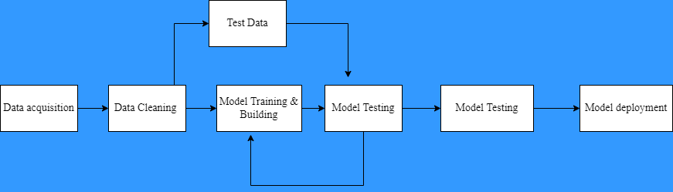

**3.4 Input Data and Feature Engineering**

Input data in supervised learning is use case specific data.Data could be structured i.e having a defined format like int, float,string or time series data as in this case,data could be semi-structured like java script object notation(json),hypertext markup language(html) etc. or data could be unstructured like images,audio,ge-spatial data.In case of semi-structured and unstructured data cleaning and pre-processing more intensive than in case of semi-structured data.However data validation,veracity check is mandatory for all forms of data.The choice of feature engineering depends on the input constraints data of the machine learning algorithm being used and the specific underlying relationship needs expression.Input variable for Stock prediction problem could be classified broadly into fundamental indicators, macroeconomic indicator and technical indicators.(Tsai and Hsiao, 2010).Fundamental indicators are derived from analysis of company fundamentals like annual statement report,balance sheet,growth forecast in the area where company operates,market capitalisation etc.Economic indicators are the macro-economic factors that indicate the health and direction of economy where the particular stock operates as the stock indexes are impacted due macro-economic scenarios.These indictors influence the demand-supply forces, investors both domestic and international confidence.Ecomonic indicators are numerous and not limited to Gross Domestic Product(GPD),GDP growth,Index of industrial production(IIP),Wholesale Price Index(WPI),monetary rates etc.

Fig 5.Input Variable types and sub-types.(Kumbure *et al.*, 2022)

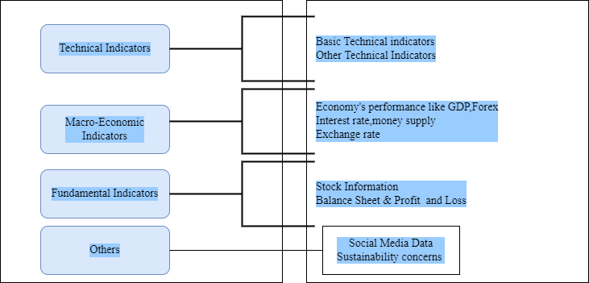

Technical indicators have traditionally been used study dynamics of stock market at granular and aggregated levels.Stock price movement is charted,measures of central tendencies derived over time to state few.They include moving averge(MA),moving average convergence and divergence(MACD),relative strength indicator(RSI) etc.(Tsai and Hsiao, 2010).

For the purpose of this study simple moving average(SMA) and relative strength indicator(RSI) are being derived from stock data.Simple moving average is the simple average of closing price of a stock for past “N” days.

$SMA\left(N\right)=\frac{{CP}_{1}+{CP}_{2}+ {CP}_{3}+ {CP}_{4}……………….. +{CP}_{N}}{N}$

Where ${CP}_{i}$ denotes price at *ith* day.

SMA provides a reliable metric providing smoothened pattern of price movement with minimal noise.SMA with *“N”* values 14,30,50,100 are popularly used.

RSI is another popular technical indicator.It is a momentum indicator that indicates the intrinsic strength of the stock.

$RSI=100-(\frac{100}{1+RS})$

$RS=\frac{Average of X days^{'}up closes}{Average of X days^{'} down closes }$

Where RS is the relative strength.

**3.5 Machine Learning Models**

Supervised Machine learning models used to solve stock price prediction problem here are regression based models.Sequential data split was done to keep the time series pattern intact.

This suits the scheme because model should learn from historical patterns,in this scheme older data is used to train the model which is tested on recent data.As it is a regression problem the Target variable is one day future closing price of stock.The models used in the study are advanced Boosting or ensemble algorithms. Such algorithms have a characteristic of having multiple hyperparameters.Hyperparamters are arguments that get supplied mostly manually by model developers.To find parameters that lead to best performance a process of hyperparamter tuning is carried out.Their are multiple hyperparameter tuning techniques like random search,Bayesian optimization,Evolutionary optimization,Grid search etc.Grid search was used for hyperparamter tuning during the study due to its generalizability and efficiency as intuitive grid values are searched. Other methods might provide results that are better and non-intuitive but require a lot of time due higher search space.

**3.5.1 eXtreme Gradient Boosting(XGBoost)**

XGBoost is tree Boosting Algorithm that has high computational efficiency and low complexity.XGBoost has proven been on leaderboard of various computational challenges due to its high accuracy.Multiple Classification and Regression Tree(CART) act as slow learners to iteratively reach results with higher accuracy.XGBoost models have regularisation term that control the variance of fit in order to keep model flexible and generalizable to avoid overfitting.(Nobre and Neves, 2019).Given the XGboost trees develop in parallel model provides for parallel computing with faster execution time.Given the data points in real trading environment could increase exponentially if the granularity set to second or hour level XGBoost model could prove robust.

**3.5.2 Random Forest**

Random forest belongs to class of ensemble models where multiple similar models are used to arrive at consensus output.Random Forest model is composed multiple decision trees which are run on bootstrapped data on random features this leads to creation weakly correlated trees as opposite to decision trees.This leads to generalised model that performs well on unseen data.

**3.5.3 Light Gradient Boosting**

**3.5.4 Ridge Regression**

**3.5.5 Elastic net Regressor**

**3.5.6 Auto-tuned Stochastic Gradient descent**